

**Network Security 2018-2019**

**Open Source Firewall Assignment  
CA 1**

**Cathal Murphy – B00095643**

**James Finglas – B00094138**

Department of Informatics

School of Informatics and Engineering

Technology Institute Dublin

Dublin 15.

Word count: 2025

(Cover page / Contents / References /Appendix/Glossary omitted from word count)

**BN311 Bachelor of Science in Computing**

**Digital Forensics & Cyber Security**

**Network Security  
16/2/2019**

Contents

1. Introduction 3

2. Attacks 4

2.1 Recon via NMAP 4

2.2 Brute Force SSH attack 7

2.3 PTunnel SSH Proxy Intrusion 8

3 Mitigation – IPTables 9

3.1 IPTables Persistence 9

3.2 SYN Attacks / Recon Mitigation 9

3.3 Brute Force SSH Mitigation 11

3.4 PTunnel SSH Proxy Intrusion Mitigation 13

4. IPCop Mitigation 14

4.1 IPCop General Info 14

4.2 SYN Attacks / Recon Mitigation 16

4.3 Brute Force SSH Mitigation 18

4.4 PTunnel SSH Proxy Intrusion Mitigation 19

5 Comparison & Conclusions 22

Appendix 23

**{i}** Going the Extra Mile **(5)** 23

Glossary 24

References 25

**Legend   
{i}** = Appendix  
**[a]** = Glossary  
**(1)** = References

# 1. Introduction

The goal of this assignment was to demonstrate our ability to learn to use IPTables, and a secondary open-source Firewall and perform an analysis and comparison between both firewalls. We selected IPCop as our second Firewall.

In addition to understanding how to configure the firewalls, we demonstrated a working understating of how Firewall rules work and demonstrated some recon/service and network attacks/proxies to show how we can then mitigate such attacks, in a way that demonstrates that we could mitigate other similar types of traffic attacks.  
  
To facilitate this assignment we built a custom internal VM**[a]** network (Due to not having access to an adequate router to simulate an external vs internal network) and we made one assumption, that we have access to name of the likely operator, ”anthony” , of the target machine we intend to attack.  
  
We assigned the following IP**[b]** addresses to our machines:

* Attacker(Debian-Linux):192.168.1.3
* Victim(Debian -Linux):192.168.1.4/(IPCop Victim = 192.168.0.4)
* Proxy(Debian -Linux):192.168.1.11
* IPCOP(Linux-generic-3xx):red-192.168.1.20/green-192.168.0.20
* Safe(Debian-Linux):192.168.1.15

We demonstrated a recon scan with mitigation, a service attack with complete mitigation, and a work-around proxy bypass of this rule through ping tunnelling, followed by another full mitigation.

# 2. Attacks

## 2.1 Recon via NMAP

Our first step is to recon the target machine using a SYN**[c]** based NMAP**[d]** scan. The command used is   
**“nmap -sV -n -v 192.168.1.4”**

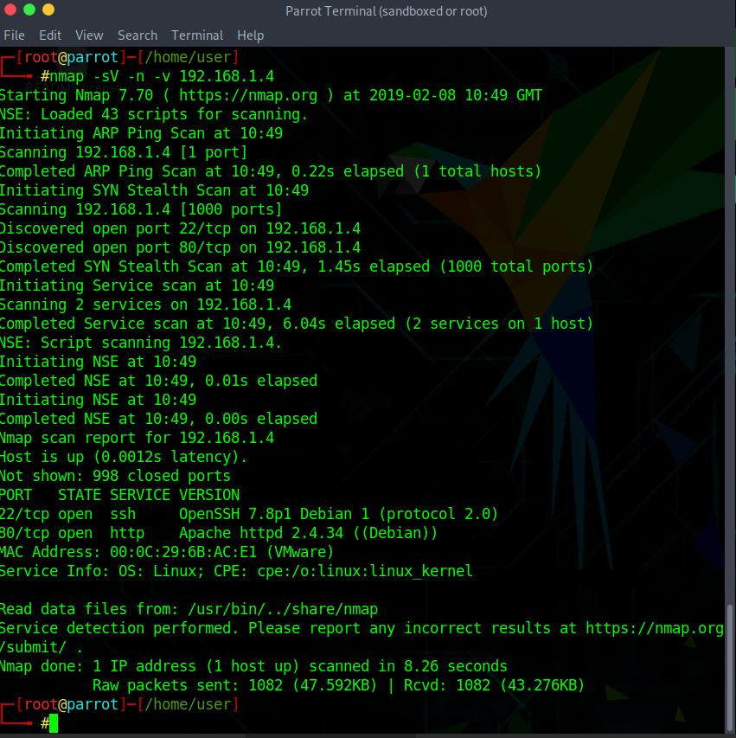

As we can see, we discovered two services, SSH**[e]** and a webserver. This is where we will focus the rest of our attacks.

Here we see the apache server up and running.

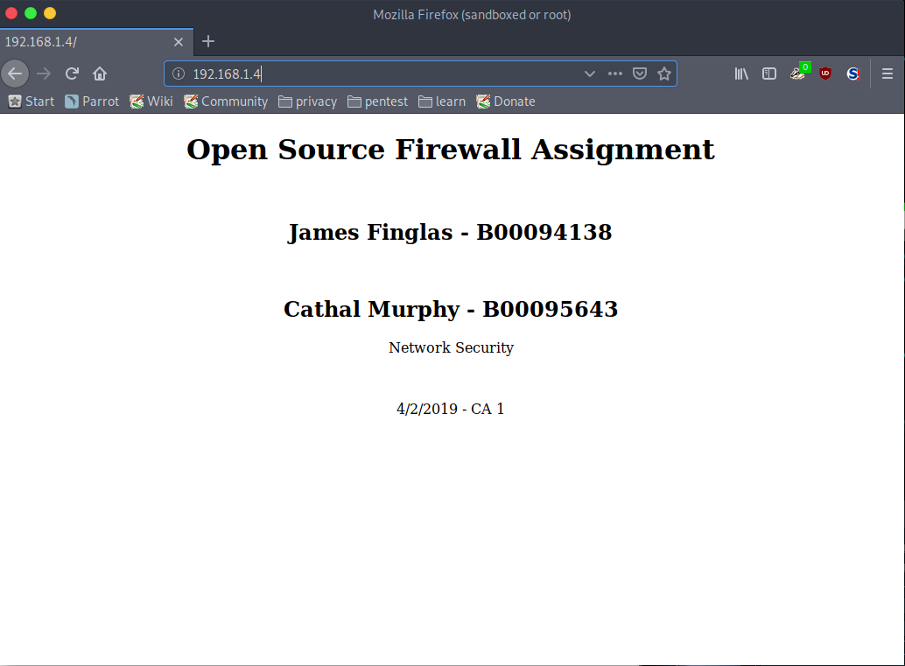

Below we see the SSH server is up and running. The command we used is “**ssh anthony@192.168.1.4”** with password “**password**” when prompted.

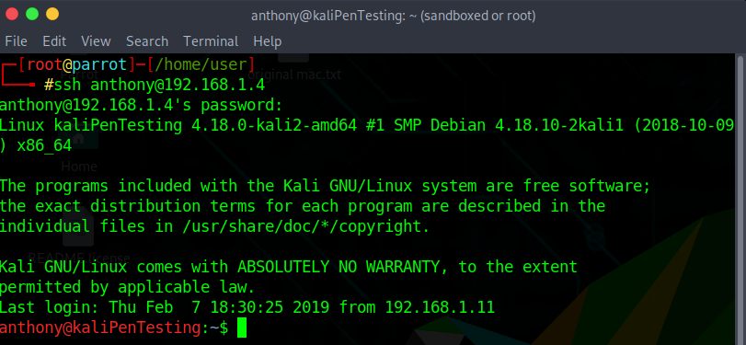

## 2.2 Brute Force SSH attack

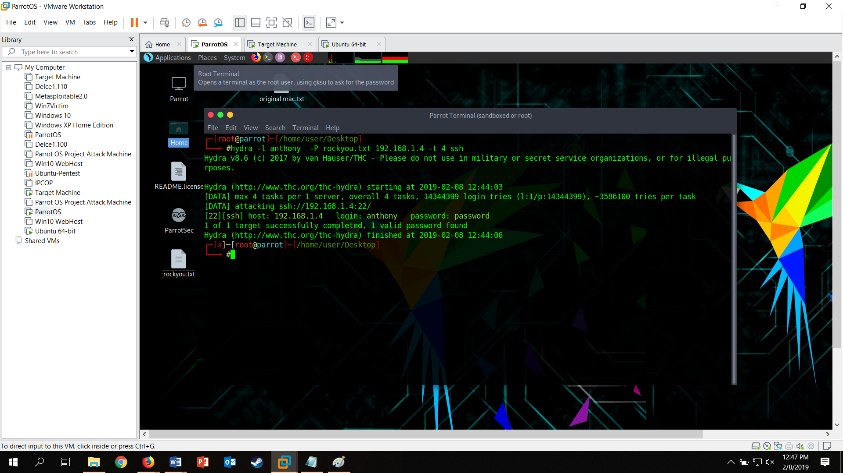Our next step is to attempt a brute force attack on the SSH server using Hydra and the word-list rockyou.txt. The command we used is “**hydra -l anthony -P rockyou.txt 192.168.1.4 -t 4 ssh”**

Here we see that hydra has successfully brute forced the SSH password**(“password”)** for the user Anthony.

## 2.3 PTunnel SSH Proxy Intrusion

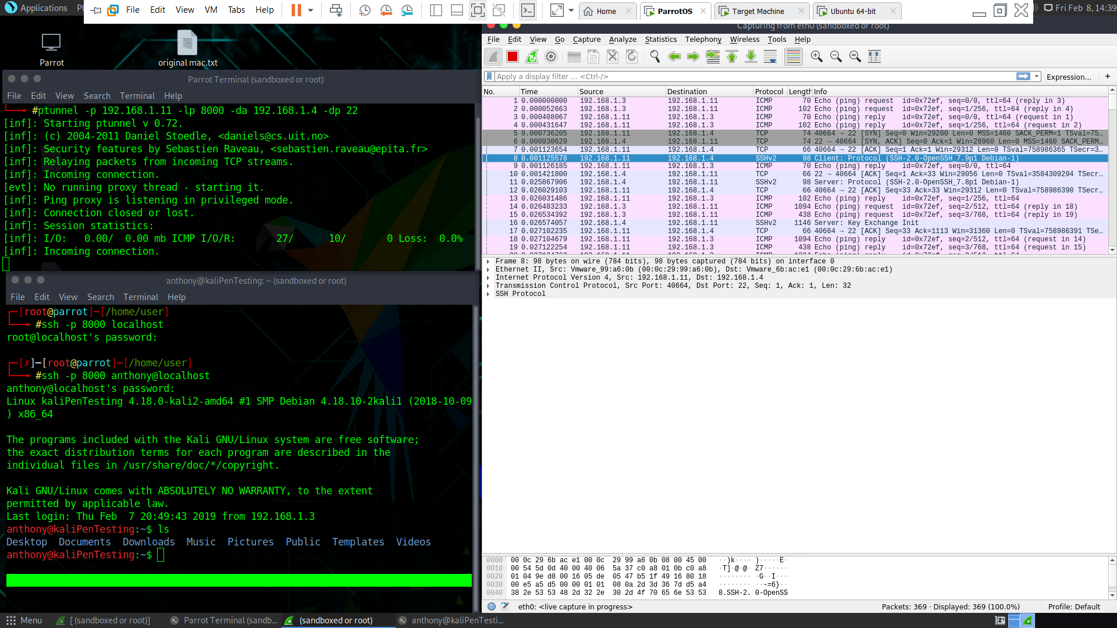Next, we used a proxy, via PTunnel, which then allowed us to connect into SSH on the victim machine. Allowing us to bypass the brute force mitigation rule, using the credentials we have obtained to legitimately log in. Our traffic will initially be disguised as a ping, which disguises the original source location of the SSH packet contained within the ping packet.

As seen in Wireshark above, ICMP**[f]**-traffic is sourced from the attack machine on 192.168.1.3(line No. 1) with a destination of 192.168.1.11(proxy machine). The traffic is then forwarded from the proxy to the victim-machine on 192.168.1.4 which establishes the connection(SSH) between our attacker and our target. Finally, traffic is returned from victim to proxy, before being forwarded onto our attack-machine. This establishes an SSH connection from attacker to victim, with the victim being unaware the attacker is connected.

# 3 Mitigation – IPTables

## 3.1 IPTables Persistence

IPTables by default discards all rules upon reloading the machine. To negate this, we installed a package called iptables-persistence which can be found here **(1)**. Once installed all a user needs to do is set up the rules for IPTables, use the save command **(sudo netfilter-persistent save)** and then when you want to load the settings use the load command **(sudo netfilter-persistent load).**

## 3.2 SYN Attacks / Recon Mitigation

To reduce the effectiveness of excessive SYN spam against a machine, the limit function must be used to reduce the amount of incoming SYN connections over TCP and drop all beyond the limit. This is done using the following commands**(2)**:

* iptables -N syn_flood
* iptables -A INPUT -p tcp --syn -j syn_flood
* iptables -A syn_flood -m limit --limit 1/s --limit-burst 3 -j RETURN
* 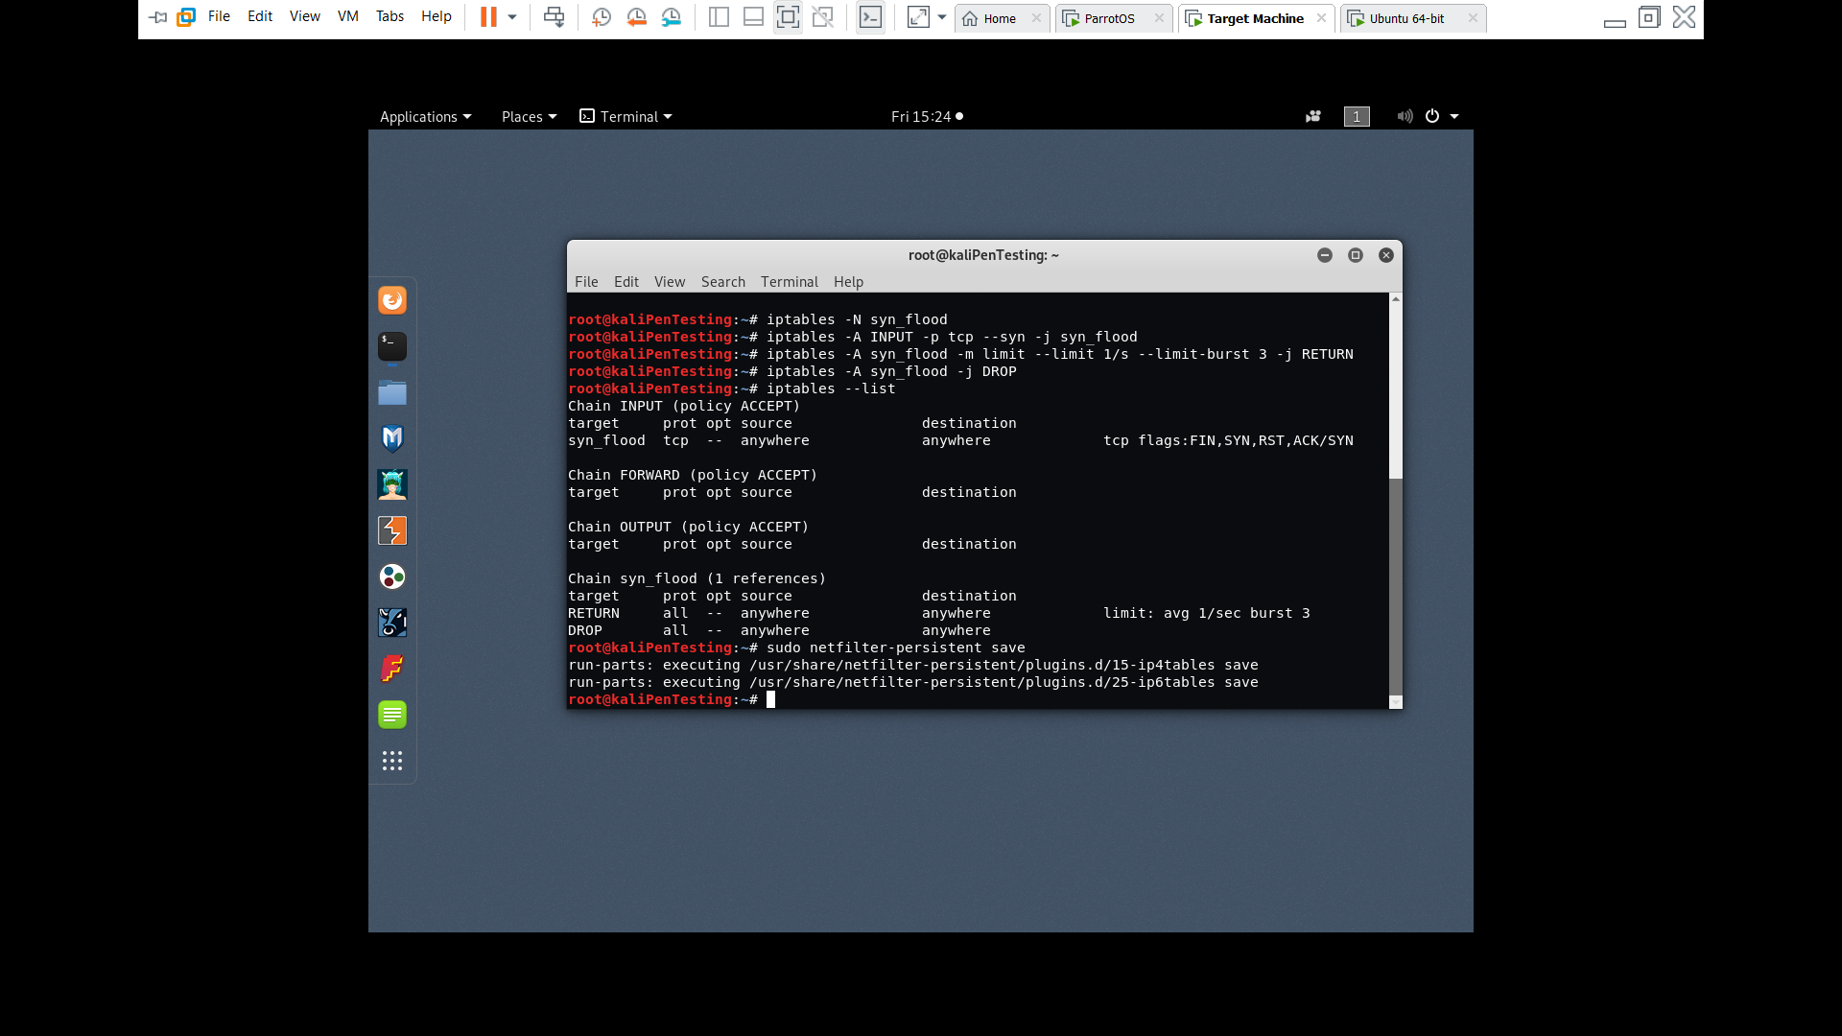 iptables -A syn_flood -j DROP

Below we see our rules applied and saved using the iptables-persistent command.

Once we applied our firewall rules we tried to launch an NMAP scan on the target again. You can see that the NMAP scan is initialized and progressively slows down reducing the likelihood of NMAP to crash services. This also mitigates several known forms of DDoS**[g]** attacks.

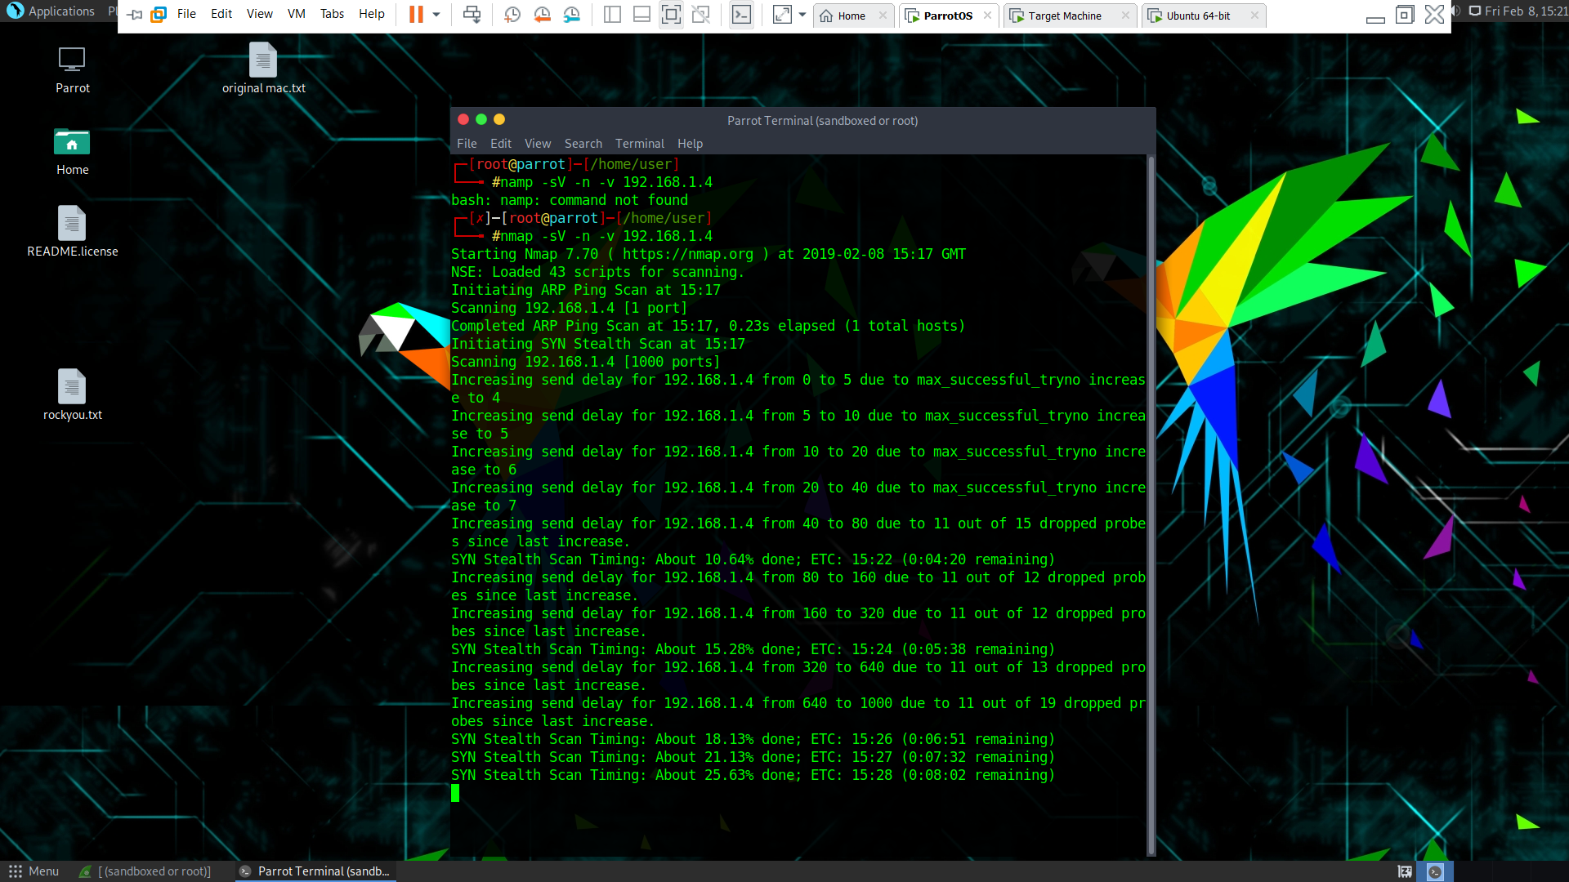

For a list of more similar rules we feel all system admins should be familiar with pertaining to network traffic please see our “Going the Extra Mile” section in this documents Appendix**{i}**.

## 3.3 Brute Force SSH Mitigation

In order to prevent the attacker connecting to SSH we added a custom inbound rule blocking the source IP(192.168.1.3) of the attacker from connecting via SSH on port-22

The command we used to do this was**(3)**:

* **iptables -A INPUT -s 192.168.1.3 -p tcp –destination-port 22 -j DROP**
* **sudo netfilter-persistent save**

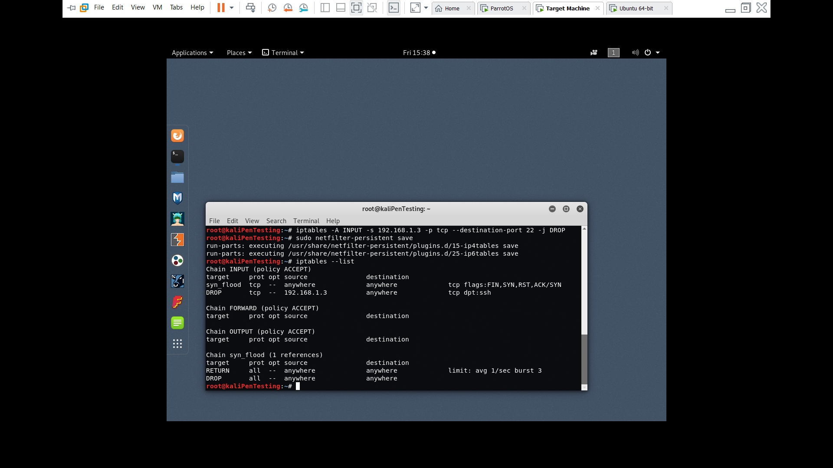

We then attempted to SSH into the victim’s machine however, our connection was dropped upon trying. As seen below, pings continued to be successful.

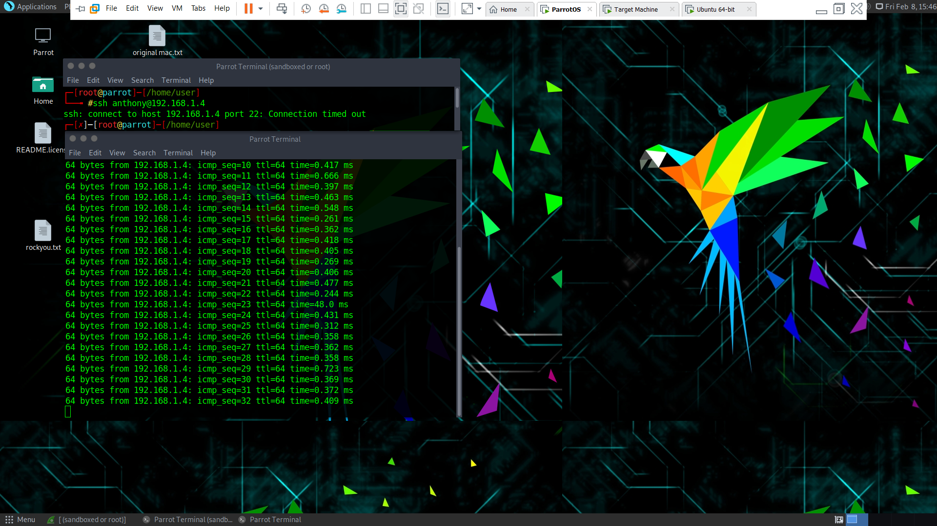

## 3.4 PTunnel SSH Proxy Intrusion Mitigation

Having already blocked our attackers access to SSH(192.168.1.3), we must now mitigate the proxy-access of the attacker as the proxy-machine is now unsafe. However, while the machine is not trusted, it also not a known attacker, as it is using correct details(acquired from our attackers brute force attack) to access SSH.

So, mitigation in this case will require a set of rules. Firstly, we block the IP of the proxies access to SSH. We also added a rule to allow a machine considered safe(IP 192.168.1.15) to connect via SSH to facilitate a legitimate remote admin login. Next, we add a rule to handle all established, related response traffic followed by a rule to allow all traffic to access the webserver on port 80. Finally, we added drop any rule to cover all other contingencies.

The commands used were**(4)**:

* **iptables -A INPUT -s 192.168.1.11 -p tcp – destination-port 22 -j DROP**
* **iptables -A INPUT -s 192.168.1.15 -p tcp – destination-port 22 -j ACCEPT**
* **iptables -A INPUT -m state –state ESTABLISHED,RELATED -j accept**
* **iptables -A INPUT -p tcp – destination -port 80 -j ACCEPT**
* 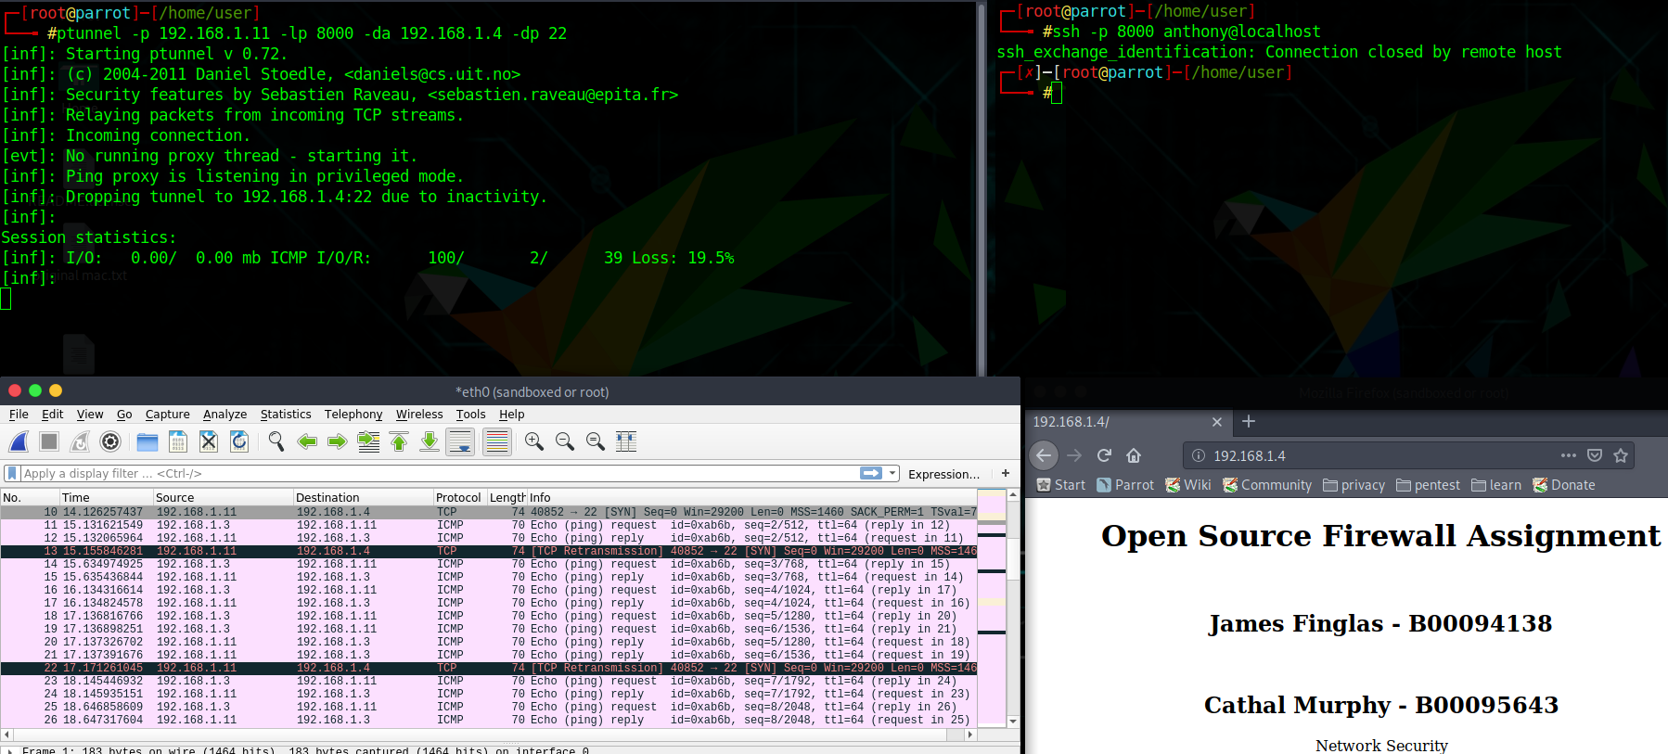**iptables -A INPUT -j DROP**

Here we can see that we our attacker can no longer tunnel through its proxy to SSH as the connection from the proxy is refused, however, it can connect to the webserver directly as can the proxy. This process would then be extended to all major services and ports as needed.

# 4. IPCop Mitigation

## 4.1 IPCop General Info

IPCop is a stand-alone OS**[h]**/Proxy-Firewall. It consists of 4 interfaces, red(in)/green(out), orange(DMZ**[i]**)/blue(WIFI**[j]**). However, IPCop’s infrastructure is overlaid onto IPTables. Therefore, we must migrate our mitigations from IPTables, into IPCop.  
  
This is simply a matter of adding the rules to the appropriate interfaces to cover both the direction of travel, service and ports we wish to protect. Some basic Rules can be added to IPTables directly and some must be added to specific interfaces.  
  
IPCop has a multitude of advanced features as displayed below, but to examine them all is far beyond the scope of this assignment due to limited word count, therefore; we will restrict ourselves to firewall rules and IPTables.

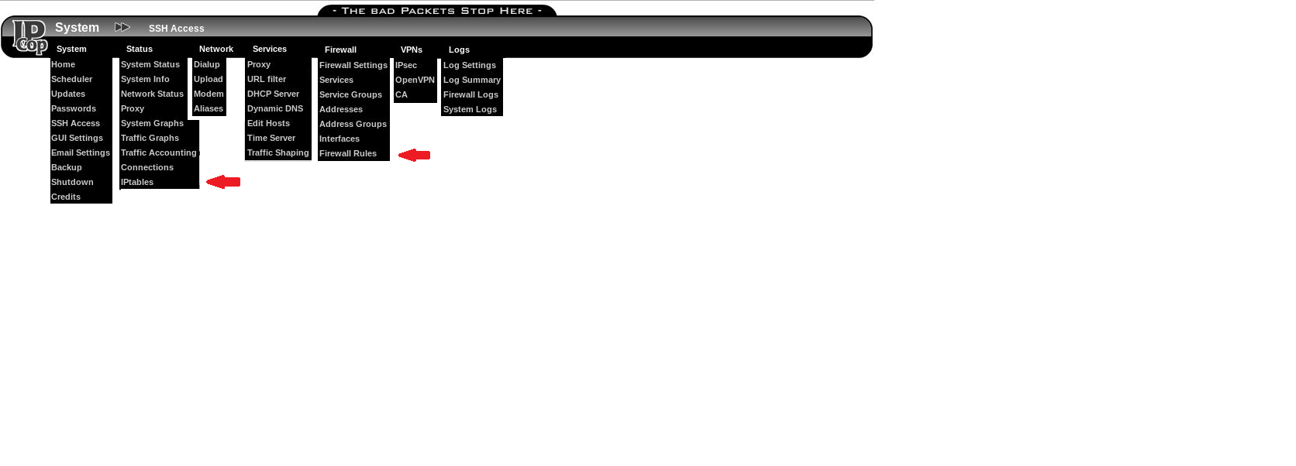

As seen below, IPCop comes preconfigured with built in rules within Iptables. We will also restrict ourselves to the red and green interfaces as there is nothing gained in adding a DMZ server and any WIFI rules would be the same as our RED interface.

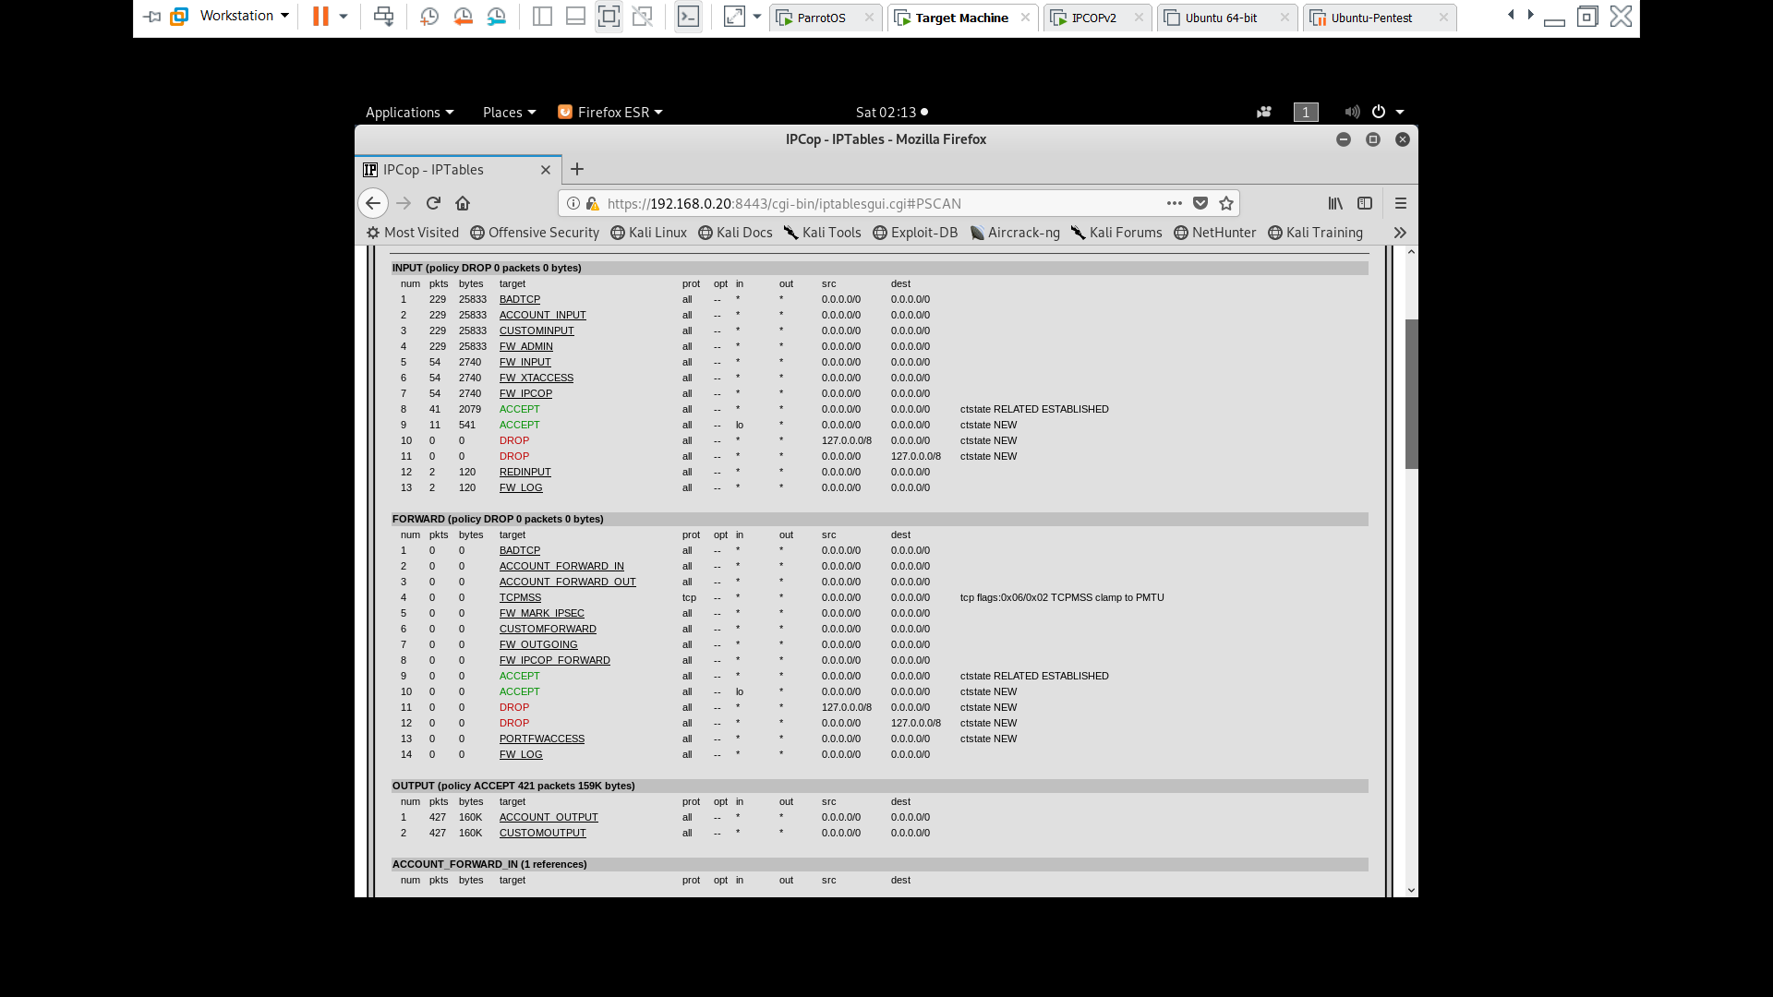

## 4.2 SYN Attacks / Recon Mitigation

To prevent SYN attacks from harming our systems, we used the limit rule as listed here.

* iptables -N syn_flood
* iptables -A INPUT -p tcp --syn -j syn_flood
* iptables -A syn_flood -m limit --limit 1/s --limit-burst 3 -j RETURN
* iptables -A syn_flood -j DROP

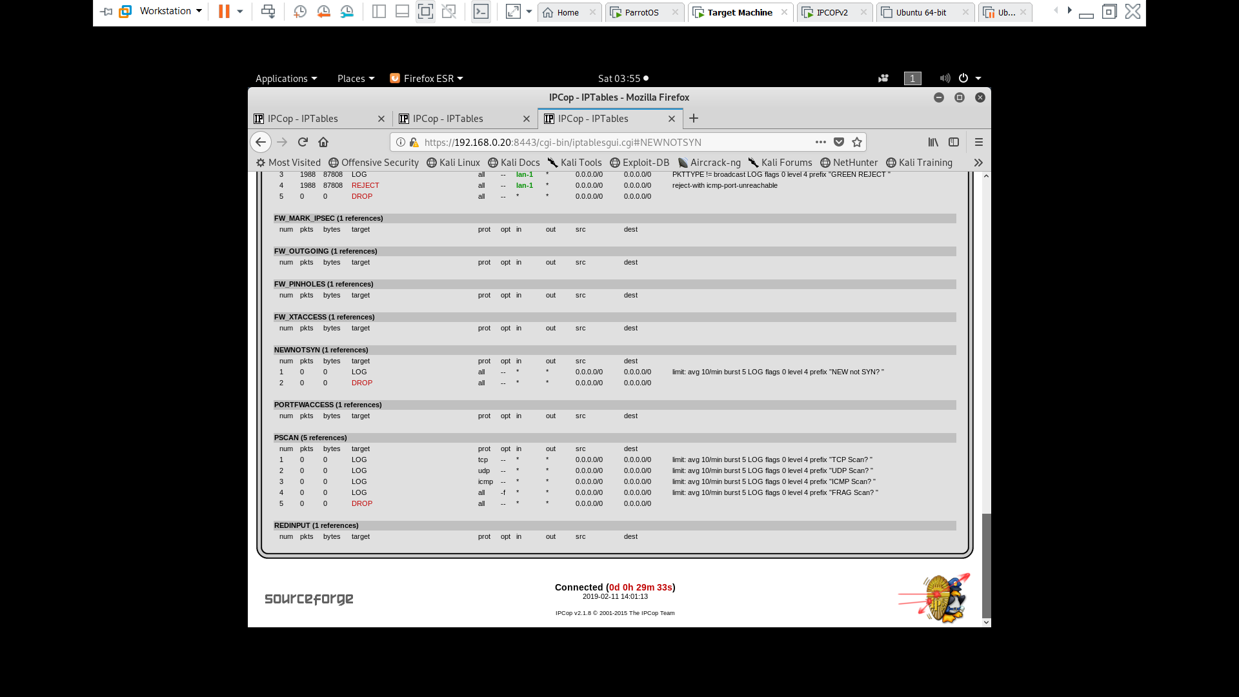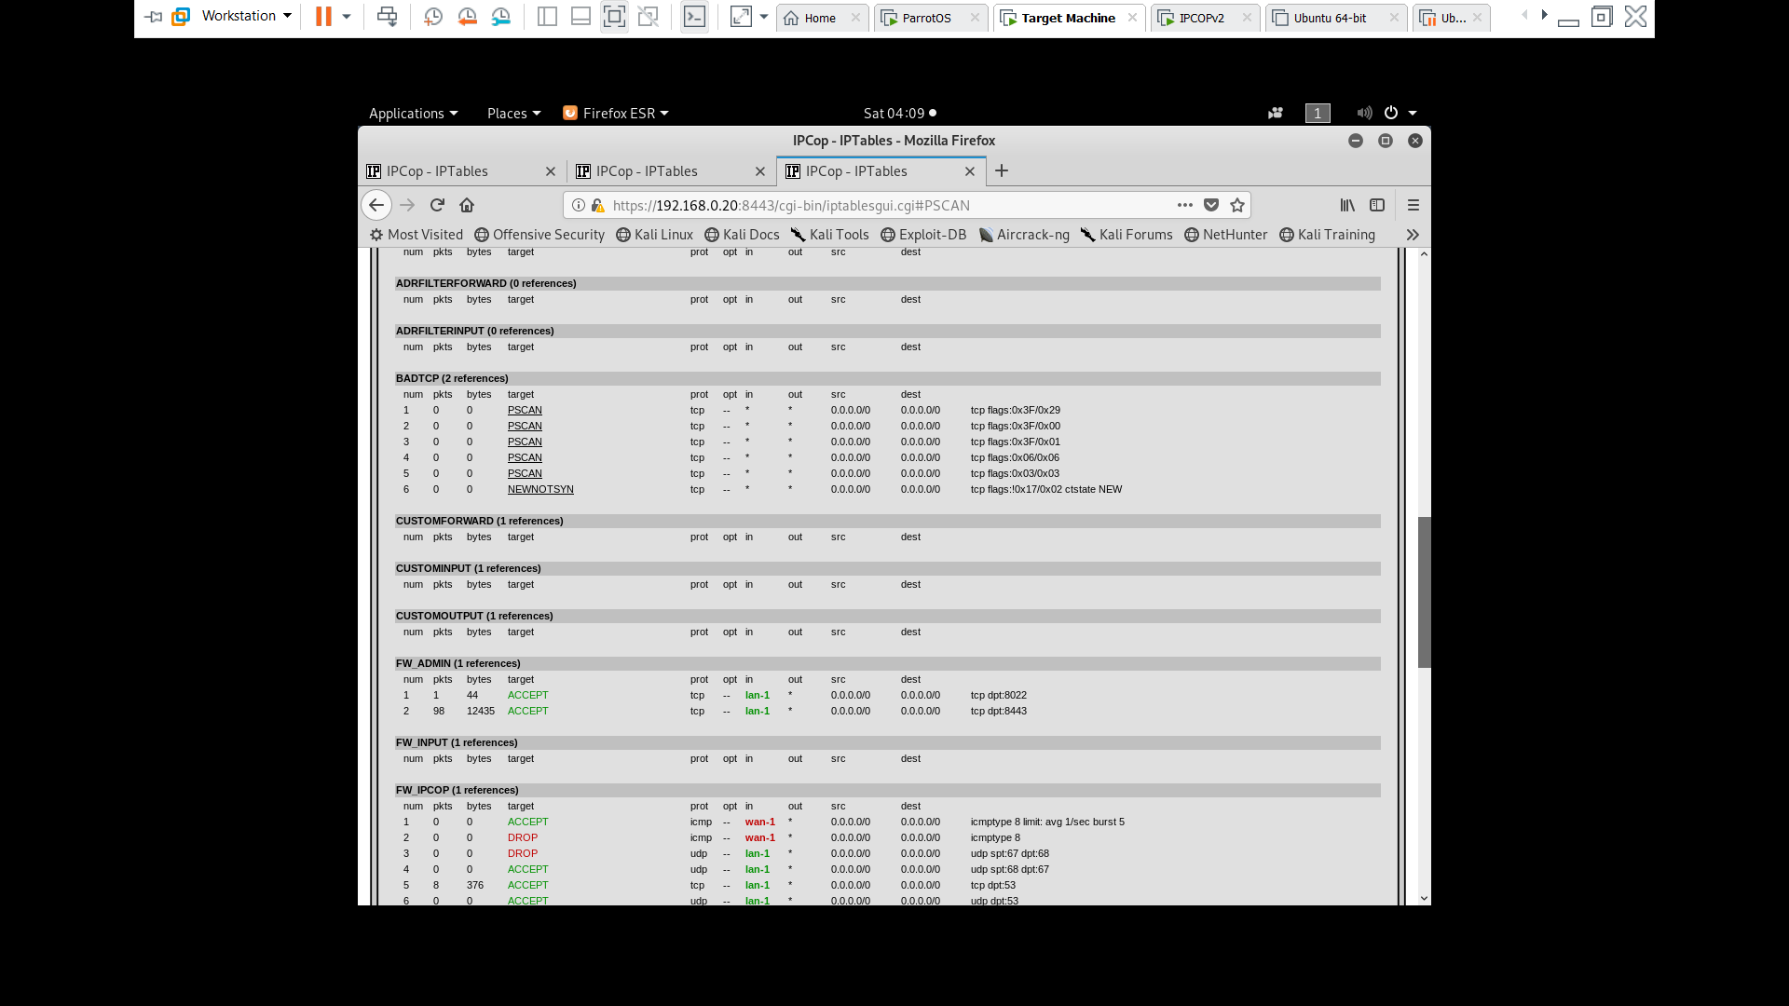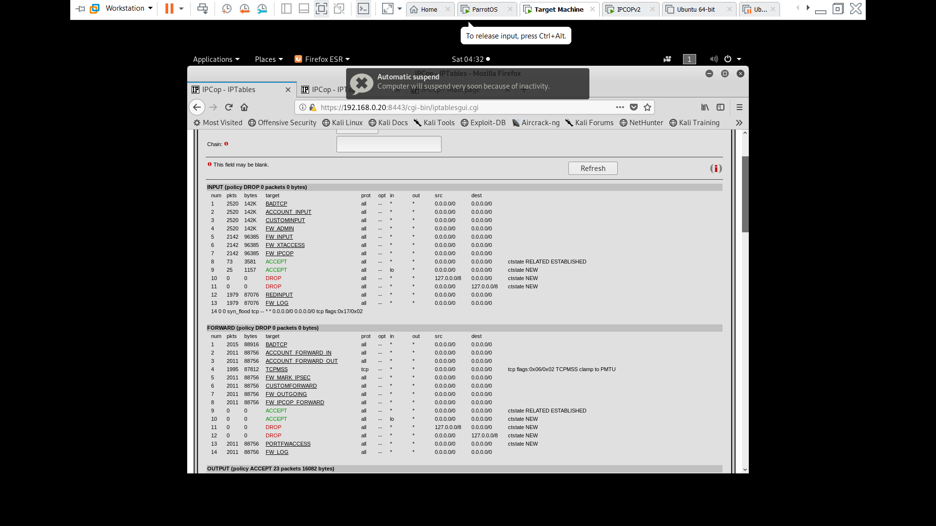However, upon closer inspection of the preconfigured firewall rules set by IPCop’s initial installation, we noticed the limit rule was already implemented to block syn flooding(albeit, with a slightly higher limit).

Verbose NEWNOTSYN information

Our SYN_FLOOD Rule

Preconfigured IPCop logging of attempted port scans & implicit drop all.

Preconfigured IPCop rule replicating our SYN_FLOOD Rule

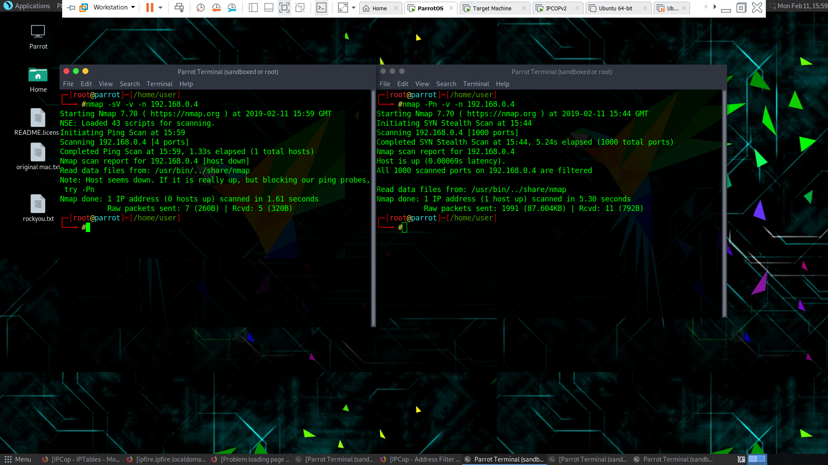After attempting an NMAP scan against the victim-machine, we see that both a SYN scan and a ping scan failed to penetrate IPCop.

## 4.3 Brute Force SSH Mitigation

We then attempted to SSH into the target machine. We got an immediate response that the connection was refused.

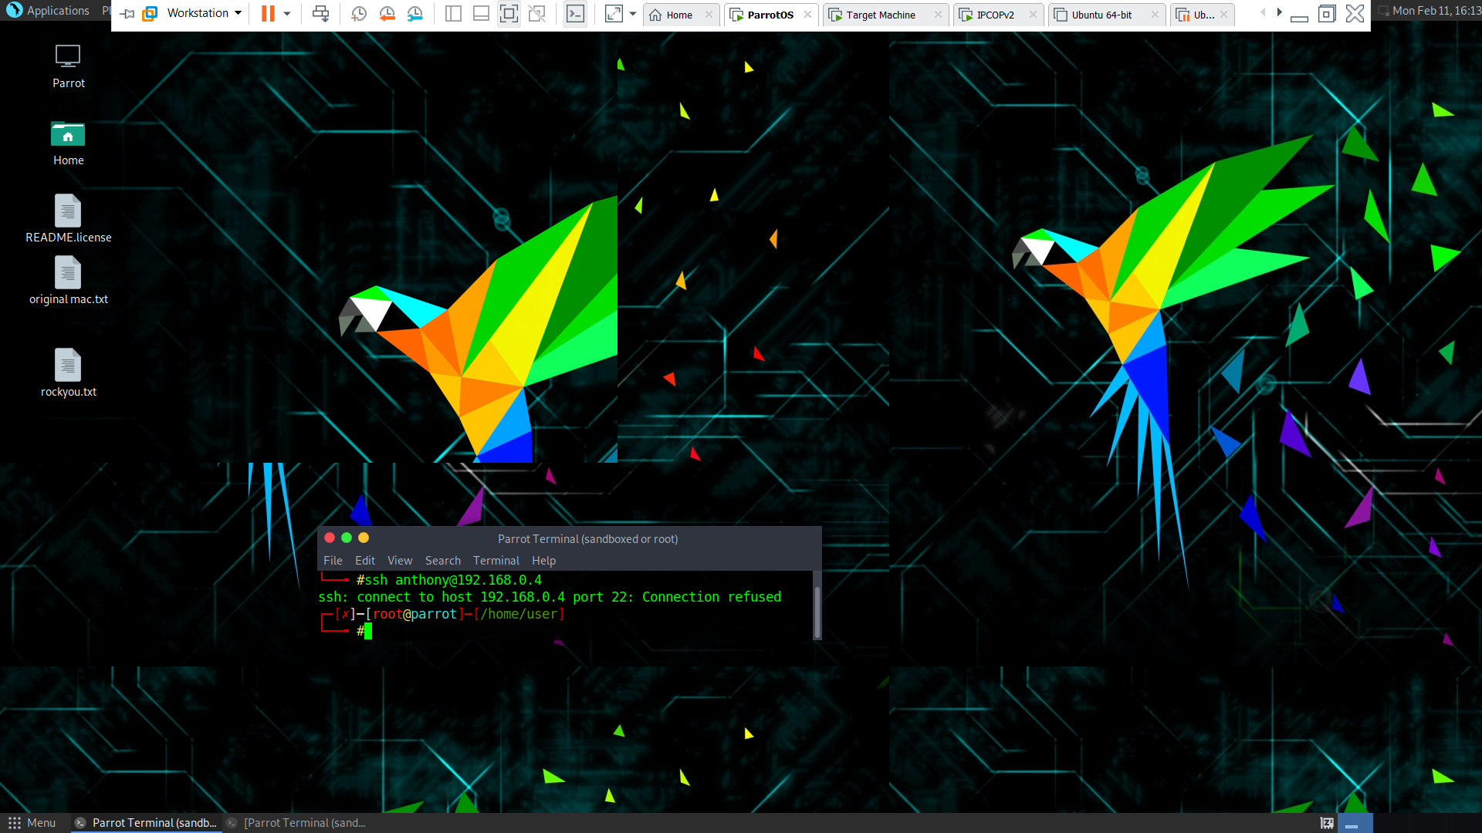



As you can see above, because SSH is not forwarded by any of the rules; it gets dropped at line number 10. This is a more excessive mitigation rule than ours therefore, no custom rules are required.

## 4.4 PTunnel SSH Proxy Intrusion Mitigation

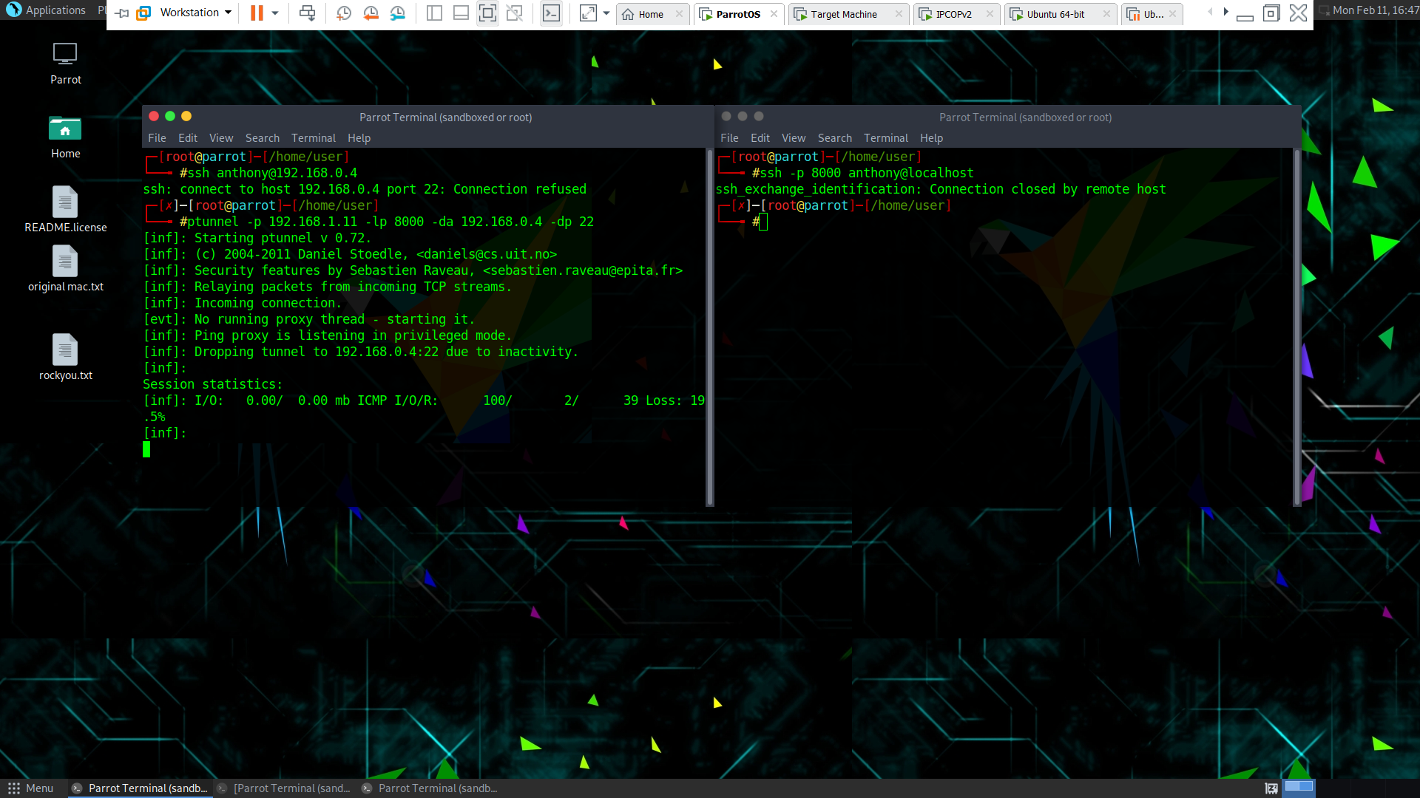As we have previously seen, the red interface blocks all. Therefore, we can expect our proxy attack to fail and as we can see below, indeed it does. Once again this is due to the implicit drop all afforded by IPCop’s default ruleset.

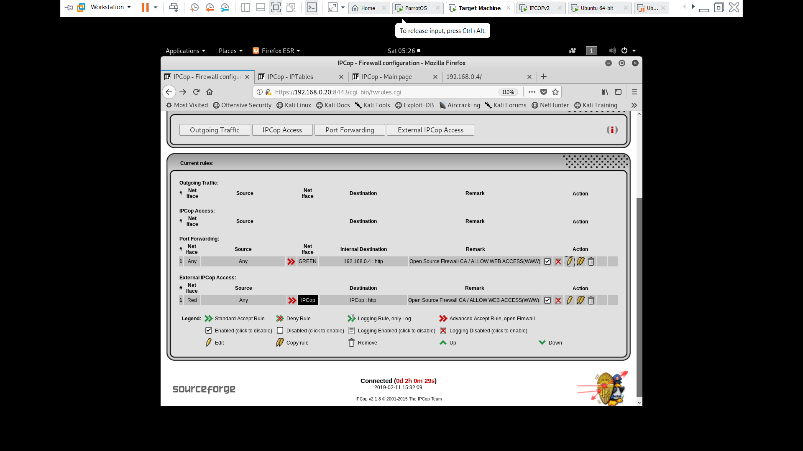Finally, we must allow our all machines access to the webserver on the victim machine through IPCop and allow one IP to SSH into our victim machine.

As we see above, the green interface has allowed all HTTP**[k]** traffic from all sources to be forwarded to the victim machine. Also IPCop on its red(Input Interface) has allowed all HTTP traffic to be accepted into IPCop; this completes the safe-bridge between users and the victim-machines webserver.

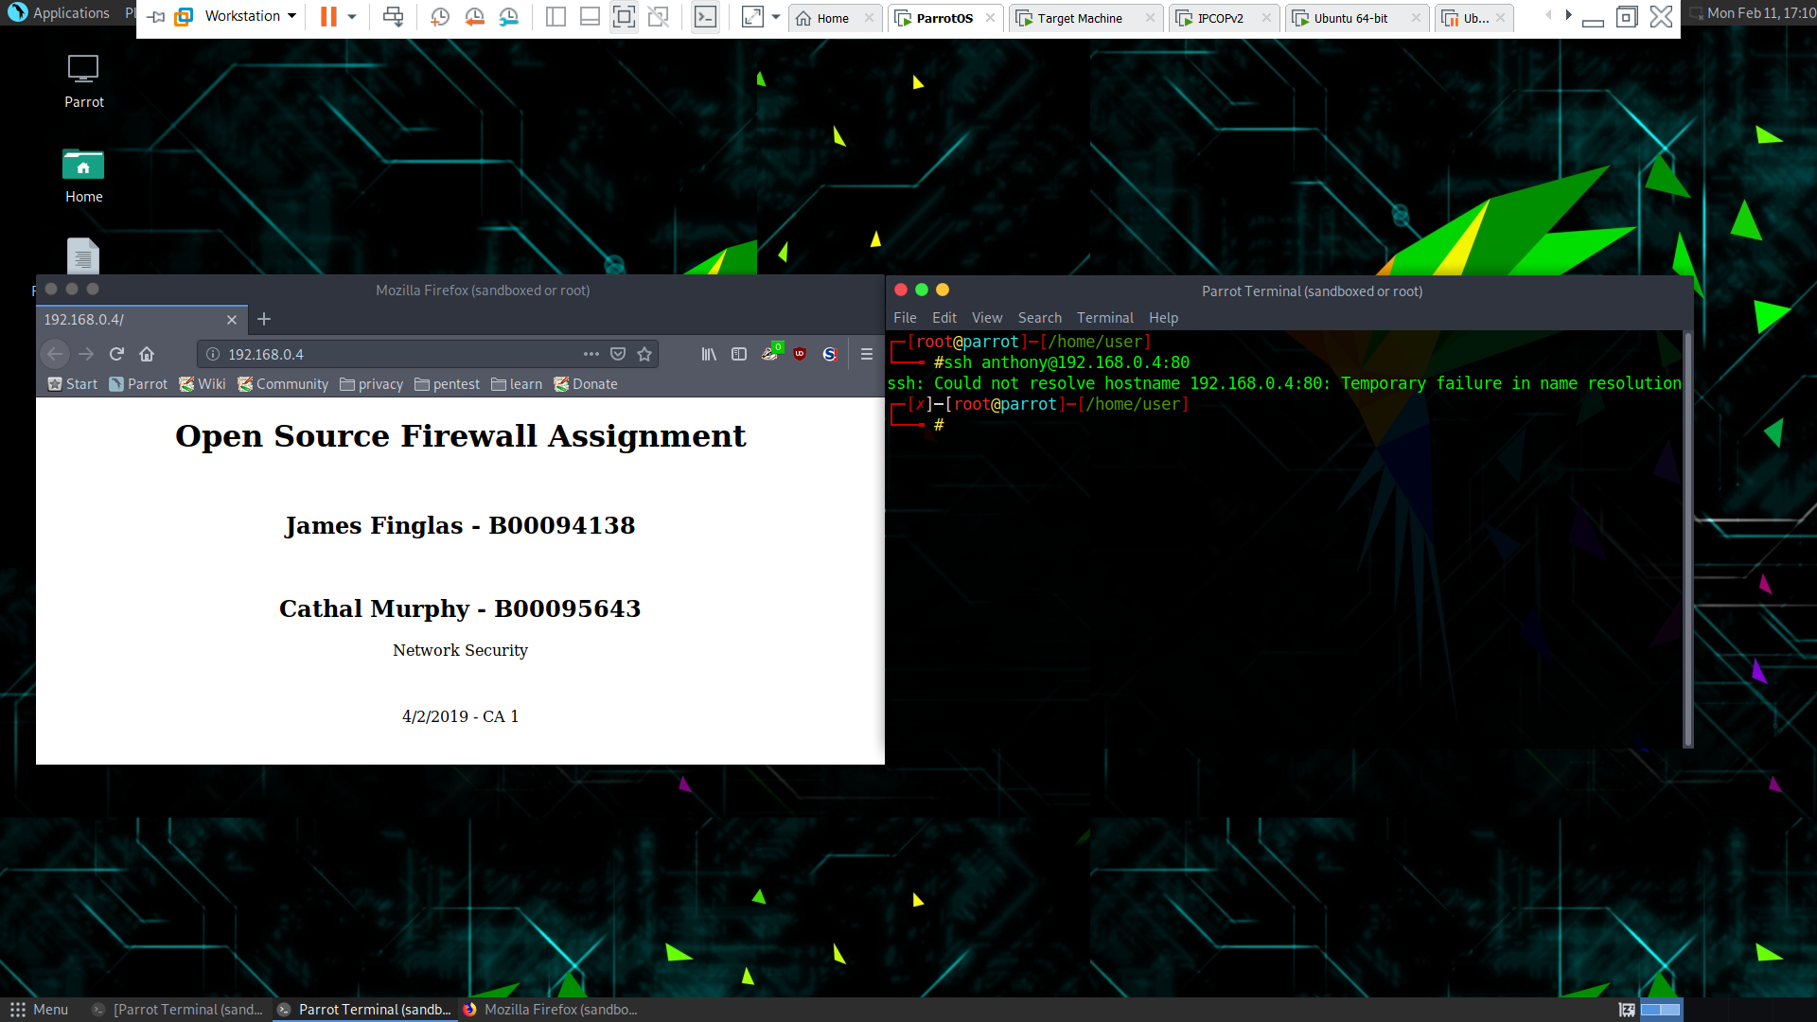As see here, our attack-machine can now access the victim’s webserver however it cannot SSH through this port.

Finally, we will add a rule to allow our safe-admin(192.168.1.15) to SSH in, this will complete our mitigation rules as performed in IPTables.

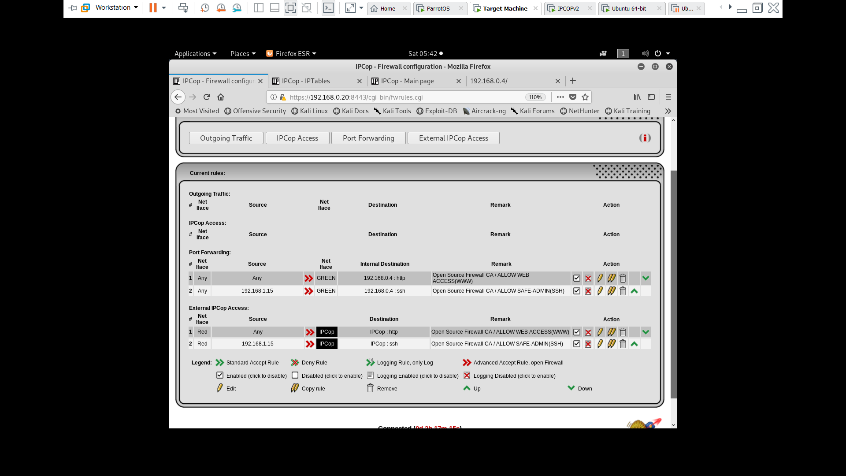

Here we see we have added custom inbound and outbound rules as done previously to allow our safe-admin to SSH through our IPCop to our victim machine.

Below, we see a successful connection form this machine via SSH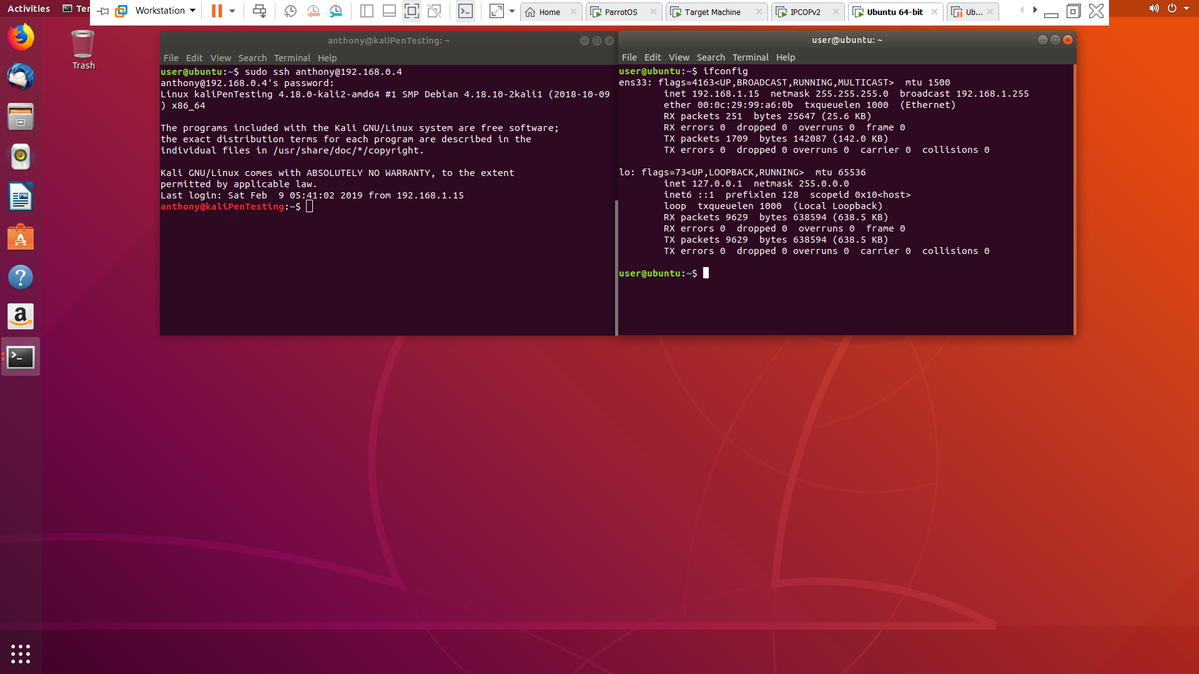

# 5 Comparison & Conclusions

IPTables is a solid, stable and reasonably customizable Firewall that adopts an allow-all and block as needed approach. It affords a vast range of adaptable protection options covering inbound and outbound rules. The ability to prohibit by service, or port rather than IP is a nice feature. This allows potentially dangerous service access to be prohibited while still providing a reasonable level of access to things like webservers. However, even in a small home environment, the best one could say about IPTables when it comes to portability and reusability is that to protect multiple machines, a script must be written then transferred. This is certainly feasible, but inconvenient and cumbersome.

While IPCop has not been updated in some time, an updated program which is the successor to IPCop does exist(IPFire). IPCop provides all the features IPTables does however, it adopts a block-all and allow as needed approach, naturally; since it incorporates IPTables. However, IPCop also offers some options IPTables cannot provide. For example, the ability to lock down one interface, and leave another open allows a user to create pseudo DMZ zones in internal networks. Furthermore, custom rules can be written to allow certain traffic, content or packets to reach one machine, while blocking said traffic from all other machines essentially allowing IPCop to act as an internal router. Most importantly, IPCop allows for rules, which can then protect a whole home network and small to medium enterprise environment.

In terms of the ease of use, both IPTables & IPCop are beyond the capabilities of novice users and the learning curve is steep initially, however; particularly for students such as us or familiar users of any Linux distribution, once the syntax had been grasped usability increased drastically, particularly as it bears a very close resemblance to Cisco IOS**[l]** router syntax.

However, as mentioned IPCop has not been maintained. Where-as IPTables does allow for updating via the Linux community. And as modern routing protocols and services evolve, most firewalling in enterprise environments happens downstream via routers. Given its age, we felt that IPCOP would need an updated IPTables with its own rules to really be sure your protected at the end user machine. This being the case, IPCop has reached its end of life. The concept of IPCop however is still very much relevant, and some companies still incorporate an IPCop or its spiritual successor(IPFire) fail-over server just in case downstream routers/Firewalls fail.  
  
This was a difficult assignment initially, but ultimately proved very useful and highly enjoyable and we greatly appreciated the opportunity to teach ourselves the use of both of these programs in mitigating attacks.

# Appendix

## **{i}** Going the Extra Mile **(5)**

As a final demonstration of our working understanding of IPTables we felt we would cover some general rules. While we will not add these rules as they do not pertain to our chosen attacks we feel they are important note-worthy rules that all system admin should add to their rulesets.

Force SYN packet check: (Drop any non SYN packets)

* **iptables -A INPUT -p tcp ! --syn -m state --state NEW -j DROP**

Ping management(allow in / out), drop all:

* **iptables -A OUTPUT -p icmp --icmp-type 0 -d 0/0 -m state --state ESTABLISHED,RELATED -j ACCEPT**
* **iptables -A OUTPUT -p icmp -o eth0 -j ACCEPT**
* **iptables -A INPUT -p icmp --icmp-type echo-reply -s 0/0 -i eth0 -j ACCEPT**
* **iptables -A INPUT -p icmp --icmp-type destination-unreachable -s 0/0 -i eth0 -j ACCEPT**
* **iptables -A INPUT -p icmp --icmp-type time-exceeded -s 0/0 -i eth0 -j ACCEPT**
* **iptables -A INPUT -p icmp -i eth0 -j DROP**

Reroute traffic from one port to another:

* **iptables -t nat -A PREROUTING -i eth0 -p tcp --dport $srcPort -j REDIRECT --to-port $dstPort**

Drop malformed XMAS packet:

* **iptables -A INPUT -p tcp --tcp-flags ALL ALL -j DROP**

Drop Null packets:

* **iptables -A INPUT -p tcp --tcp-flags ALL NONE -j DROP**

Drop all forwarded Traffic:

* **iptables -A FORWARD -j DROP**

# Glossary

1. VM: Virtual Machine
2. IP: Internet Protocol
3. SYN: Synchronized message in TCP**[m]**
4. NMAP: Network Mapper
5. SSH: Secure Shell
6. ICMP: Internet Control Message Protocol
7. DDoS: Deliberate Denial of Service
8. OS: Operating system
9. DMZ: De-Militarized Zone
10. WIFI: Wireless Network Connection
11. HTTP: Hypertext Transfer Protocol
12. IOS: Internetwork Operating System
13. TCP: Transmission Control Protocol

# References

1. IPTables-persistence Debian-git-repository**:** <https://salsa.debian.org/debian/iptables-persistent>
2. Commands and documentation on how to limit SYN scans/attacks: <https://www.cyberciti.biz/tips/howto-limit-syn-attacks.html>
3. Commands to block IP access to a service/port: <https://www.cyberciti.biz/faq/how-do-i-block-an-ip-on-my-linux-server/?fbclid=IwAR1wuRxO-hWSLO2L6srutjGncH8iUzFhQQifVj25GFswz8LWMHSnbV6eRVo>
4. IPTables – Linux man page: <https://linux.die.net/man/8/iptables>
5. Going the Extra Mile References:  
   1. Important general rules regarding Ping, Malformed XMAS, Null and SYN packets: <https://www.cyberciti.biz/tips/tag/ping-of-death>
   2. Also, as answered by karthick87, Dec15 2010, 10:11pm on ask ubuntu here: <https://askubuntu.com/questions/17548/how-can-i-block-ping-requests-with-iptables>
   3. Also as answered by tachomi, Jan 21 2016, on unix stack exchange: <https://unix.stackexchange.com/questions/256853/drop-all-traffic-and-forward-traffic-from-one-port-to-another-with-iptables>